Experiment Number : 05 Date: 05.02.2026

INHERITANCE
Aim:
To understand and implement inheritance concepts in Java.
PRE LAB EXERCISE
QUESTIONS
- What is inheritance?
Inheritance is a Object-Oriented Programming (OOP) concept where one class (child) acquires the properties and methods of another class (parent).
It helps create a hierarchy between classes.
- What is code reusability?
Code reusability means using existing code again instead of writing it from scratch.
It reduces repetition, saves time, and avoids errors.
- What is the use of extends keyword?
The extends keyword is used in Java to create a child class from a parent class.
It allows the child class to inherit variables, methods, and behavior of the parent.
IN LAB EXERCISE
Objective:
To implement all types of inheritance.

PROGRAMS:
Student Result System (Single Inheritance)
Question:
A school wants to store student details and calculate marks. Create a base class Student and a derived class Result.
Code:
class Student {
String name;
int rollNo;

void getDetails() {
name = "Anitha";
rollNo = 101;
}
}

class Result extends Student {
int marks = 85;

void display() {
System.out.println("Name: " + name);
System.out.println("Roll No: " + rollNo);
System.out.println("Marks: " + marks);
}
}

public class Main {
public static void main(String[] args) {
Result r = new Result();
r.getDetails();
r.display();
}
}
Output: 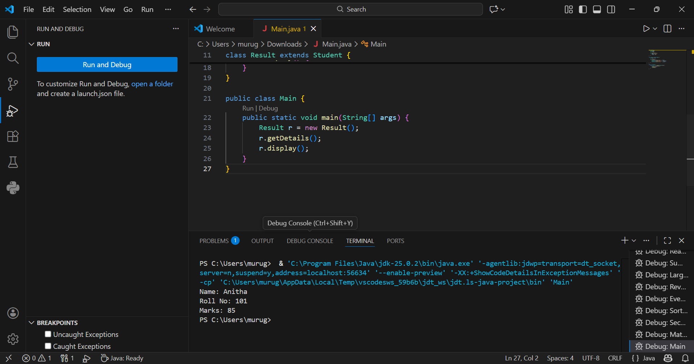
Name: RAM
Roll No: 101
Marks: 85

2. Bank Account System (Hierarchical Inheritance)
Question:
A bank has Savings and Current accounts. Both inherit from a common Account class.
Code:
class Account {
void showAccountType() {
System.out.println("Bank Account");
}
}

class SavingsAccount extends Account {
void interest() {
System.out.println("Savings Account gives interest");
}
}

class CurrentAccount extends Account {
void overdraft() {
System.out.println("Current Account supports overdraft");
}
}

public class Main {
public static void main(String[] args) {
SavingsAccount s = new SavingsAccount();
CurrentAccount c = new CurrentAccount();

s.showAccountType();
s.interest();

c.showAccountType();
c.overdraft();
}
}

Output: 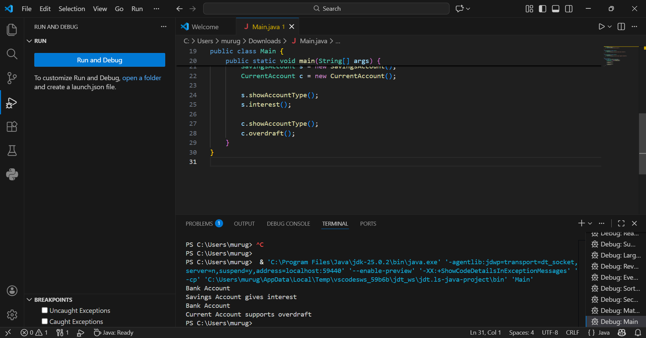
Bank Account
Savings Account gives interest
Bank Account
Current Account supports overdraft

3. Vehicle System (Multilevel Inheritance)
Question:
A company classifies vehicles as Vehicle → Car → ElectricCar.
Code:
class Vehicle {
void start() {
System.out.println("Vehicle starts");
}
}

class Car extends Vehicle {
void fuelType() {
System.out.println("Car uses petrol");
}
}

class ElectricCar extends Car {
void battery() {
System.out.println("Electric car uses battery");
}
}

public class Main {
public static void main(String[] args) {
ElectricCar e = new ElectricCar();
e.start();
e.fuelType();
e.battery();
}
}
Output: 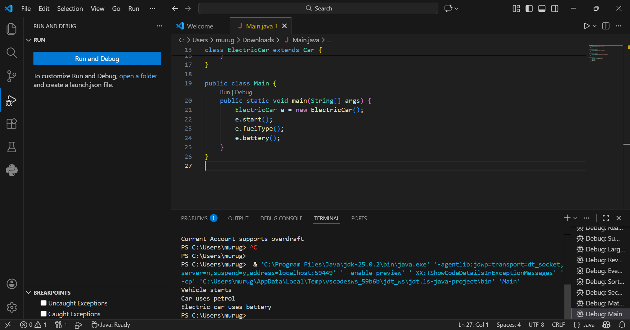
Vehicle starts
Car uses petrol
Electric car uses battery
POST LAB EXERCISE
- Why Java does not support multiple inheritance using classes and how it is implemented?
Java does not support multiple inheritance with classes because it creates ambiguity (Diamond Problem).
Instead, Java implements multiple inheritance through interfaces, allowing a class to implement multiple interfaces without conflict.
- What is the role of the super keyword? Give examples.
The super keyword is used to access parent class members.It is used to call the parent constructor, parent methods, and parent variables.
Example:
super.x; // parent variable
super.display(); // parent method
- Can a child class access private members of the parent class? Why?
No, a child class cannot directly access private members because private members are restricted to the same class only.
They can be accessed indirectly using getter/setter methods.
- Explain why hybrid inheritance is not supported in Java.
Hybrid inheritance is not supported because it leads to method ambiguity and diamond problem.
Java avoids this complexity by allowing hybrid inheritance only through interfaces, not classes.
Result:

Thus the different types of inheritance were implemented and executed successfully.

ASSESSMENT

Description | Max Marks | Marks Awarded
Pre Lab Exercise | 5
In Lab Exercise | 10
Post Lab Exercise | 5
Viva | 10
Total | 30
Faculty Signature

